**2403A51238**

**T.chandana**

**Question1**:

Write a python code to caluculate the sum if odd and even numbers in a given list using GitHub copilot

Along with vs code.Use zero shot prompting.

**Prompt**:

Calculate the sum of odd and even numbers in a list

**Code:**

def sum_odd_even(numbers):

even_sum = 0

odd_sum = 0

for num in numbers:

if num % 2 == 0:

even_sum += num

else:

odd_sum += num

return even_sum, odd_sum

# Example usage

numbers = [1, 2, 3, 4, 5, 6]

even_sum, odd_sum = sum_odd_even(numbers)

print("Sum of even numbers:", even_sum)

print("Sum of odd numbers:", odd_sum)

**Output:**

Sum of even numbers: 12

Sum of odd numbers: 9

**Code Screenshot:**

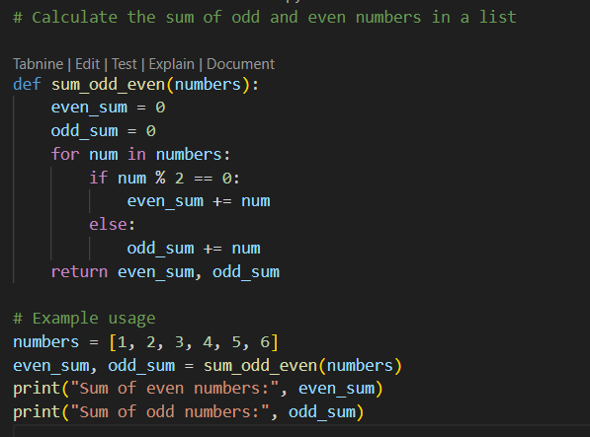

**Output:**

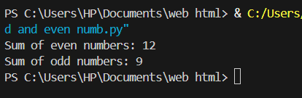

**Question 2:**

Write a Python code for given a list of integers, remove duplicates and print the sorted

result. GitHub Copilot along with VS Code. Use one shot prompting.

**Prompt:**

Given a list of integers, remove duplicates and print the sorted result.

**Code:**

nums = [5, 3, 8, 3, 1, 5, 7, 2, 8]

# Remove duplicates and sort the list

unique_sorted = sorted(set(nums)

print(unique_sorted)

**Output:**

[1, 2, 3, 5, 7, 8]

**Code screen shot:**

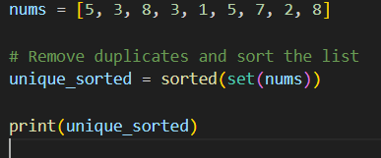

**Output:**



**Question 3:**

Write a Python function that converts the temperature between Celsius, Fahrenheit

and Kelvin based on user choice. Use the Cursor AI tool. Use few shot prompting.

**Prompt**:

Write a function that converts the temperature between Celsius, Fahrenheit, and Kelvin

based on user choice.

**Code:**

def convert_temperature(value, from_unit, to_unit):

u_from = from_unit.strip().upper()

u_to = to_unit.strip().upper()

valid = {'C', 'F', 'K'}

if u_from not in valid or u_to not in valid:

raise ValueError("Units must be 'C', 'F', or 'K'.")

if u_from == u_to:

return float(value)

if u_from == 'C':

c = float(value)

elif u_from == 'F':

c = (float(value) - 32.0) * 5.0 / 9.0

else: # 'K'

c = float(value) - 273.15

if u_to == 'C':

return c

elif u_to == 'F':

return c * 9.0 / 5.0 + 32.0

else: # 'K'

return c + 273.15

# Make sure you actually call and print:

print(convert_temperature(100, 'C', 'F'))

**Output:**

212.0

**Code Screenshot:**

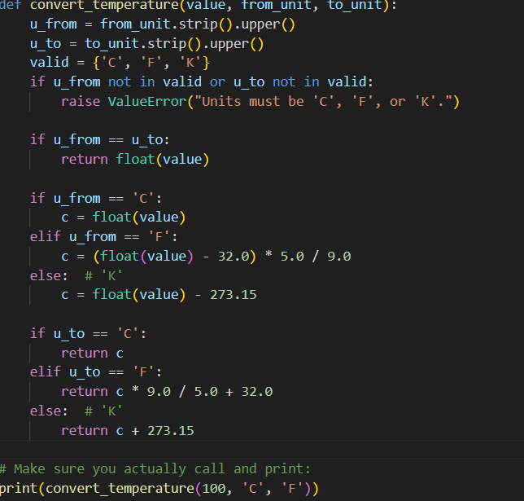

**Output:**



**Question 4:**

Write a Python function to remove punctuation, convert to lowercase, and remove stop

words from a given text. Use the Cursor AI tool. Use zero shot prompting.

**Prompt:**

**ZERO SHOT PROMPT GIVEN IN CURSOR AI TOOL:**

Write a Python function to remove punctuation, convert to lowercase, and remove

stop words from a given text.

**Code:**

import string

from typing import Iterable, Set

# A sensible default English stopword set. You can pass your own via the function arg.

DEFAULT_STOPWORDS: Set[str] = {

"a", "an", "the", "and", "or", "but", "if", "while", "with", "without", "of", "at", "by",

"for", "to", "from", "in", "on", "off", "over", "under", "into", "out", "as", "is", "are",

"was", "were", "be", "been", "being", "do", "does", "did", "doing", "have", "has", "had",

"having", "that", "this", "these", "those", "it", "its", "it's", "i", "you", "he", "she",

"they", "them", "we", "us", "your", "yours", "his", "her", "their", "my", "mine", "me",

"our", "ours", "not", "no", "so", "too", "very", "can", "could", "should", "would", "will",

"just", "than", "then", "there", "here", "also", "because", "about", "up", "down", "out",

}

def preprocess_text(text: str, stopwords: Iterable[str] | None = None) -> str:

"""Return text lowercased, without punctuation, and without stop words.

- Converts the entire input to lowercase

- Removes ASCII punctuation characters defined in string.punctuation

- Removes tokens that are in the provided stopword set (or DEFAULT_STOPWORDS)

Args:

text: Arbitrary input text.

stopwords: Optional iterable of stop words to remove. Defaults to DEFAULT_STOPWORDS.

Returns:

A cleaned string containing whitespace-separated tokens.

"""

if not isinstance(text, str):

raise TypeError("text must be a string")

stopword_set: Set[str] = set(s.lower() for s in (stopwords if stopwords is not None else DEFAULT_STOPWORDS))

# Lowercase first so stopword comparison is consistent

lowered_text = text.lower()

# Remove punctuation using translate for speed

translator = str.maketrans('', '', string.punctuation)

text_without_punct = lowered_text.translate(translator)

# Tokenize on whitespace and filter stopwords

tokens = text_without_punct.split()

filtered_tokens = [token for token in tokens if token not in stopword_set]

return " ".join(filtered_tokens)

if name == "main":

sample = "This is, perhaps, the simplest Example: removing Punctuation & Stop-Words!"

print(preprocess_text(sample))

**Output:**

Perhaps simplest example removing punctuation stopwords

**Code Screenshot:**

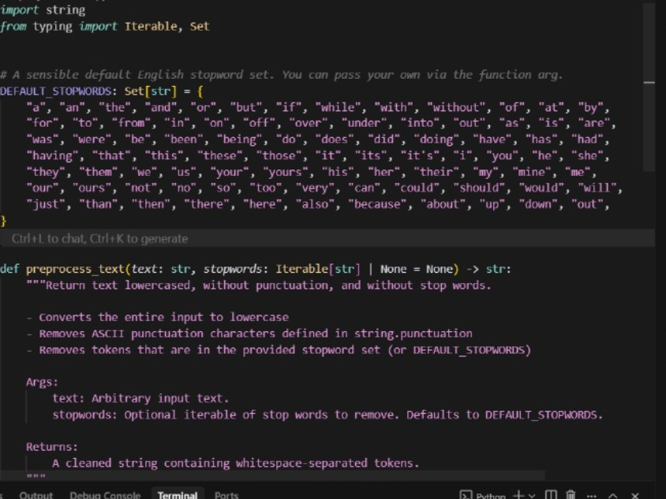

**Output:**

